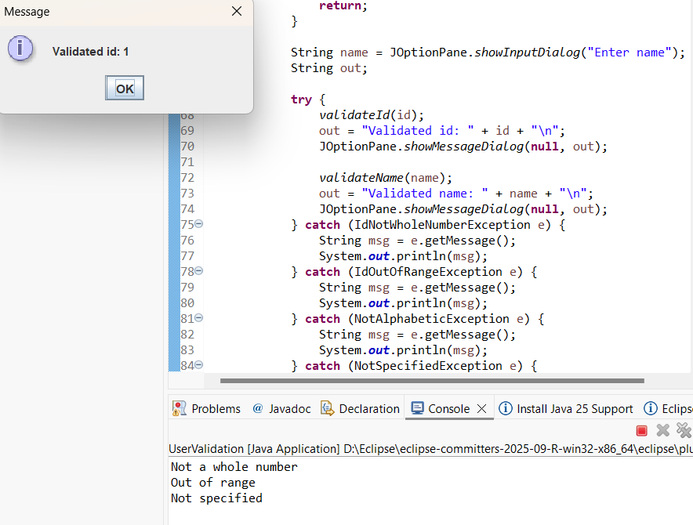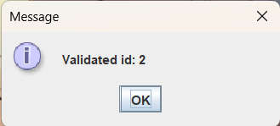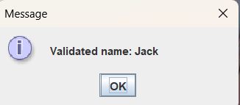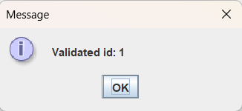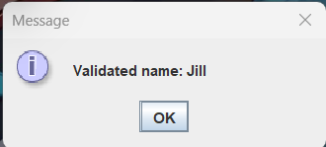
package as13;

import javax.swing.JOptionPane;

public class UserValidation {

// Exception classes
public static class IdNotWholeNumberException extends Exception {
public IdNotWholeNumberException() {
super("Not a whole number");
}
}

public static class IdOutOfRangeException extends Exception {
public IdOutOfRangeException() {
super("Out of range");
}
}

public static class NotAlphabeticException extends RuntimeException {
public NotAlphabeticException() {
super("Not alphabetic");
}
}

public static class NotSpecifiedException extends RuntimeException {
public NotSpecifiedException() {
super("Not specified");
}
}

// Validation methods
public static void validateId(String sId)
throws IdNotWholeNumberException, IdOutOfRangeException {
int idInt;
try {
idInt = Integer.parseInt(sId);
} catch (NumberFormatException ex) {
throw new IdNotWholeNumberException();
}

if (idInt < 1 || idInt > 999) {
throw new IdOutOfRangeException();
}
}

public static void validateName(String name) {
if (name.equals("")) {
throw new NotSpecifiedException();
} else if (!name.matches("[a-zA-Z]+")) {
throw new NotAlphabeticException();
}
}

// Main method
public static void main(String[] args) {
while (true) {
String id = JOptionPane.showInputDialog("Enter Id");
if (id.equalsIgnoreCase("0")) {
JOptionPane.showMessageDialog(null, "Bye");
return;
}

String name = JOptionPane.showInputDialog("Enter name");
String out;

try {
validateId(id);
out = "Validated id: " + id + "\n";
JOptionPane.showMessageDialog(null, out);

validateName(name);
out = "Validated name: " + name + "\n";
JOptionPane.showMessageDialog(null, out);
} catch (IdNotWholeNumberException e) {
String msg = e.getMessage();
System.out.println(msg);
} catch (IdOutOfRangeException e) {
String msg = e.getMessage();
System.out.println(msg);
} catch (NotAlphabeticException e) {
String msg = e.getMessage();
System.out.println(msg);
} catch (NotSpecifiedException e) {
String msg = e.getMessage();
System.out.println(msg);
}
}
}
}

